Week 3 – Chiaroscuro & Value: the Dark and the Light

CRITIQUE #2: NEGATIVE SPACE DRAWING
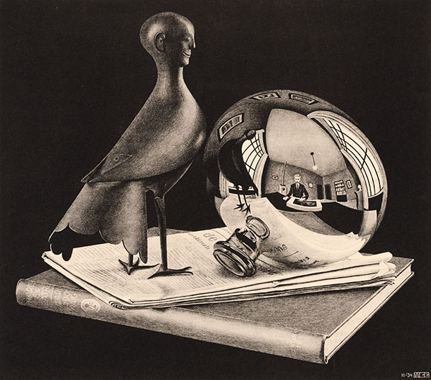MC Escher Still Life with Spherical Mirror 1934
Tonight when you are showing your drawing(s), be prepared to discuss your subject matter, your composition, and your use of positive and negative space.
What did you learn from this exercise? Has it made you SEE differently?

There are three things I can recommend if you want to improve your eye as an artist and therefore improve your artwork:
1. Do an exercise more than once. It takes time and practice to get better. The first time you approach an assignment, treat it as an opportunity to learn more about yourself. The second time, you learn more about your medium and materials. The third time, you will start to pull together what you know and what you see. By the fourth time, the problem seems easier to solve with a truly good composition. I know it can be time consuming to work on something over and over! So start with small drawings-- I love to draw images 2x3 inches (same size as my engraving blocks!)- that’s small enough to work quickly; but big enough to get detail or practice tricky techniques. From there I can choose successful images to enlarge or technical details to include in a final work.
2. Be open and receptive to this feedback if you are serious about improving your skills as an artist and designer. Remember that you have until the next grading period to make any necessary changes or additions or to try again.
3. TAKE NOTES!! Get in the habit of taking critique notes in your sketchbook (not just on your own work, but your classmates’ work as well.) You may see a particular style, a great idea you want to pursue further or some technique that you would like to incorporate into your own work.

Critiques are also your teaching moment — you can share your understanding and experience with your peers.

Presentations: Into the Dark & Out of the Light
Still Life: More than just a pile of stuff
Terms:
- Hatching
- Cross Hatching
- Stippling
- Scribbling
- Scumbling
- Pattern
- Texture
- Value the most important thing that value does is to help us represent 3-dimensional forms on a 2-dimensional surface.
- Contrast
- Proximity
- Emphasis (Focus)
- Emotion Impact or Mood
- Chiaroscuro
- Depth of Field (Illusion of Depth)
- Atmospheric Perspective (aerial perspective) refers to the effect the atmosphere has on the appearance of an object as it is viewed from a distance. As the distance between an object and a viewer increases, the contrast between the object and its background decreases, and the contrast of any markings or details within the object also decreases. The colors of the object also become less saturated and shift towards the background color, which is usually blue, but under some conditions may be some other color (for example, at sunrise or sunset distant colors may shift towards red).
- Gradation- different values softly blend into each other, gradually moving from light to dark in continuous grades of tone.
- Vanitas a type of symbolic still life painting in Flanders and the Netherlands in the 16th and 17th centuries Paintings executed in the vanitas style were meant to remind viewers of the transience of life, the futility of pleasure, and the certainty of death. They often included objects that made reference to the five senses.
___________________________________________________________________________________________________________________________
NOTES:

Activity F Hatching, Crosshatching, Scribbling, Stippling 10 points
Create practice examples of hatching, crosshatching, scribbling and stippling with different media. Try your Micron pen and Sharpie Ultra Fine Point markers and any other media you have with you. Start with a light shade of gray and building up gradually to full coverage that creates the darkest dark or black. Try starting dark and going lighter using the scratchboard sample to think in reverse.
Label each of the four techniques at least once on your inked sample.

Activity G Value Strips with Ink 10 points
In this activity, you will create a full range of value using each of the 4 techniques. You must leave white space between each box.
These value strips will be a useful reference to check your “range of value” in future drawings.

Introduction to Chiaroscuro
Chiaroscuro is a method of drawing continuous grades of value to show form (from the Italian “chiaro” for light and “oscuro” for black).
Chiaroscuro is best observed with one light source with light objects when you are just learning to see the subtle differences in tones.
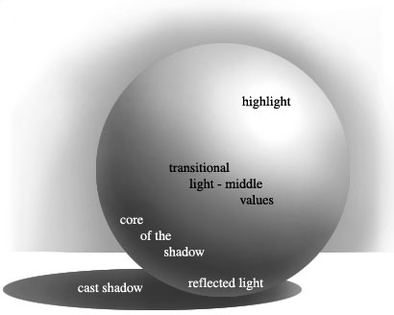
The 7 elements of chiaroscuro are: Approx. Values
1. Highlight — the lightest value on a surface that is illuminated ……………………… …0%
(Most often white or the lightest shade of local color)

2. Light — the illumination of the object (the value of the actual object) …………………20-40%

3. Shadow — blocked area of illumination ……………………………………………………… 40-60%

4. Core of Shadow — center area of the shadow (most concentrated) …………… 60-80%

5. Reflected light — Light that is bounced from a reflective surface ………………… 40%

6. Reflected shadow — A shadow that bounces back from a nearby surface 60%

7. Cast Shadow — A shadow thrown onto an adjacent plane or object ………… 80-100%
(The cast shadow is not part of the form, but it helps to define it.)

Activity H Chiaroscuro Drawings of Eggs 10 points
You will create 2 ink chiaroscuro drawings of a white egg. Each of the eggs will be rendered with one of the four techniques: hatching, crosshatching, scribbling or stippling (choose two). Divide a sketchbook page in half and use a pencil to lightly sketch the outline of an egg on each side. Draw large, but don’t forget to leave room for cast shadows.
Using the chiaroscuro handout as reference, you will demonstrate the 7 elements of chiaroscuro on each egg, in ink, using your two chosen techniques.

You must use the same ink pen for the whole egg.
As you work, keep in mind where the light source is. Your line work or patterned strokes should curve around and follow the form. (Think about the cross contour sketches and how the lines helped “round out” the forms.) Try for smooth transitions between the values; avoid banding or striping of your tonal values.

Why do comic book images look so flat? OUTLINES!! So while it is fine to indicate some edges in the dark area as a dark line, do not completely outline shapes in inked lines, as this will flatten out your mid-tones and especially your highlights and negate your chiaroscuro. GO SLOW-- be careful not to go too dark too quickly; these are white objects. Remember that an eraser can also be a drawing tool-- when working in pencil, you can “reverse draw” by creating erased highlights. Ink is less forgiving- you can’t erase, so start filling in your gray tones slowly. Think about starting with your mid-tone and working toward the light and then working on the dark areas
Label each egg with the technique you chose. On one of the eggs you will also label all 7 elements of chiaroscuro: highlight, light, shadow, core of shadow, reflected light, reflected shadow, cast shadow.

For Next Week:
- Complete Assessment #3 for critique. See handout for details.
- Bring in a 3-dimensional object to draw.
- Bring in your graphite pencils (hard and soft), blending stumps, and kneaded eraser.
- Reminder: Your sketchbooks are due in 2 weeks – collected at week 5 so I can grade everything from Weeks 1-4.
_______________________________________________________________________________________________
NOTES

