WEEK 4: Drawing and Un-Drawing: Chiaroscuro with Pencil & Eraser

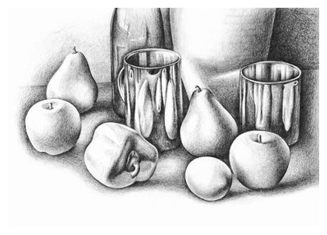
Critique of Assessment #3 -- Ink Value Drawing
When you pin up your finished piece this week, and pin up your thumbnail sketches. We want to see your thought processes, how you arrived at your composition and choices for shadows and highlights.
Be prepared to answer questions about your compositional choices, your light source, and your use of the four ink techniques to show value.
What meaning did you try to incorporate into your still life? What are you trying to say? Did the values and lighting help this message?
Remember if you are not pleased with your piece; you still have until next week to make any necessary changes, additions or complete reworkings.

NEXT WEEK: MAKE SURE YOUR SKETCHBOOK IN ORDER, LABELLED and COMPLETE!
I will look for all exercises to be completed and done well and neatly. Assessment images need to be mounted neatly and handouts and notes placed in proper order. Don’t forget your name!!

PRESENTATION: PENCIL TALK--Introduction to Graphite Pencils

Activity I: Value Grid Handout 10 points
Before you begin your Value Grid exercise, experiment with all your graphite pencils—start with the hard (H) leads and then start with t the softer (B) leads—to become familiar with this dry media. Examine the visual characteristics as you vary pressure and stroke length. Try some of the mark making techniques we did in ink. Which work well with pencil? Which give less satisfactory marks by comparison?
- Notice the gray color and sheen, - how is 3B different in coverage and color from 3H?
- Label the different pencil strokes if you wish (4B, 2B, HB, 2H, etc.) Try building up value gradually.
- Try smudging the pencil marks-- which pencils leads lend themselves best to smudging and blending with fingers or stumps?
- Experiment with reverse drawing (aka Erasing!) Thinking in reverse about the gray scale as we did with the scratchboards. This technique called ”subtractive tone” is just removing the graphite to create highlights or patterns in darker areas

Activity J Value Drawing of Object 10 points
Now that you’ve created a range of value, you will practice gradually transitioning these different values into each other to represent a 3-dimensional form. You will recall that his method of drawing is called chiaroscuro. Last week you created eggs with ink; today you will render a detailed value drawing of the object you brought from home, using various graphite pencils. Pure chiaroscuro is difficult to see in the classroom lighting conditions (because of the multiple light sources), but do your best to pick out the subtle value changes on your object. Place white paper under your object if you are having trouble seeing the cast shadow(s). Be sure to draw large, filling at least half your page. Use your hard and soft pencils to render all highlights, mid tones and shadows that define the form. Don’t forget about your cast shadow(s), which are not part of the form but help to define it. Use your blending stumps/fingers to blend. Unless your object is all one color (which it probably isn’t), you need to account for the different colors (values) on it. There should be no evident line work (like hatching or crosshatching) and very little white paper showing through on your object, except in the highlights. You can also use the technique of subtractive tone — removing value with an eraser to achieve highlights. Your kneaded eraser is a great tool for this. Try to achieve a nice range of value within your drawing, and smooth transitions between values. Avoid using sharp outlines around your object. (This tends to flatten it out rather than give it dimension.) Also keep in mind that shiny, metallic or glass surfaces tend to have sudden changes in value from very dark to very light; whereas rough, textured surfaces tend to have more subtle value changes. You may want to take a photo of your object with your cell phone if you need more time to work on it at home. (Remember the lighting will be different there.) When you are finished with your drawing, compare it to your value strips from Activity I. Do you have a full range of value represented in your drawing, or do you need to “push” your darks even darker?

NOTES.

Assessment #4 Value Drawing of 3 Objects 50 points
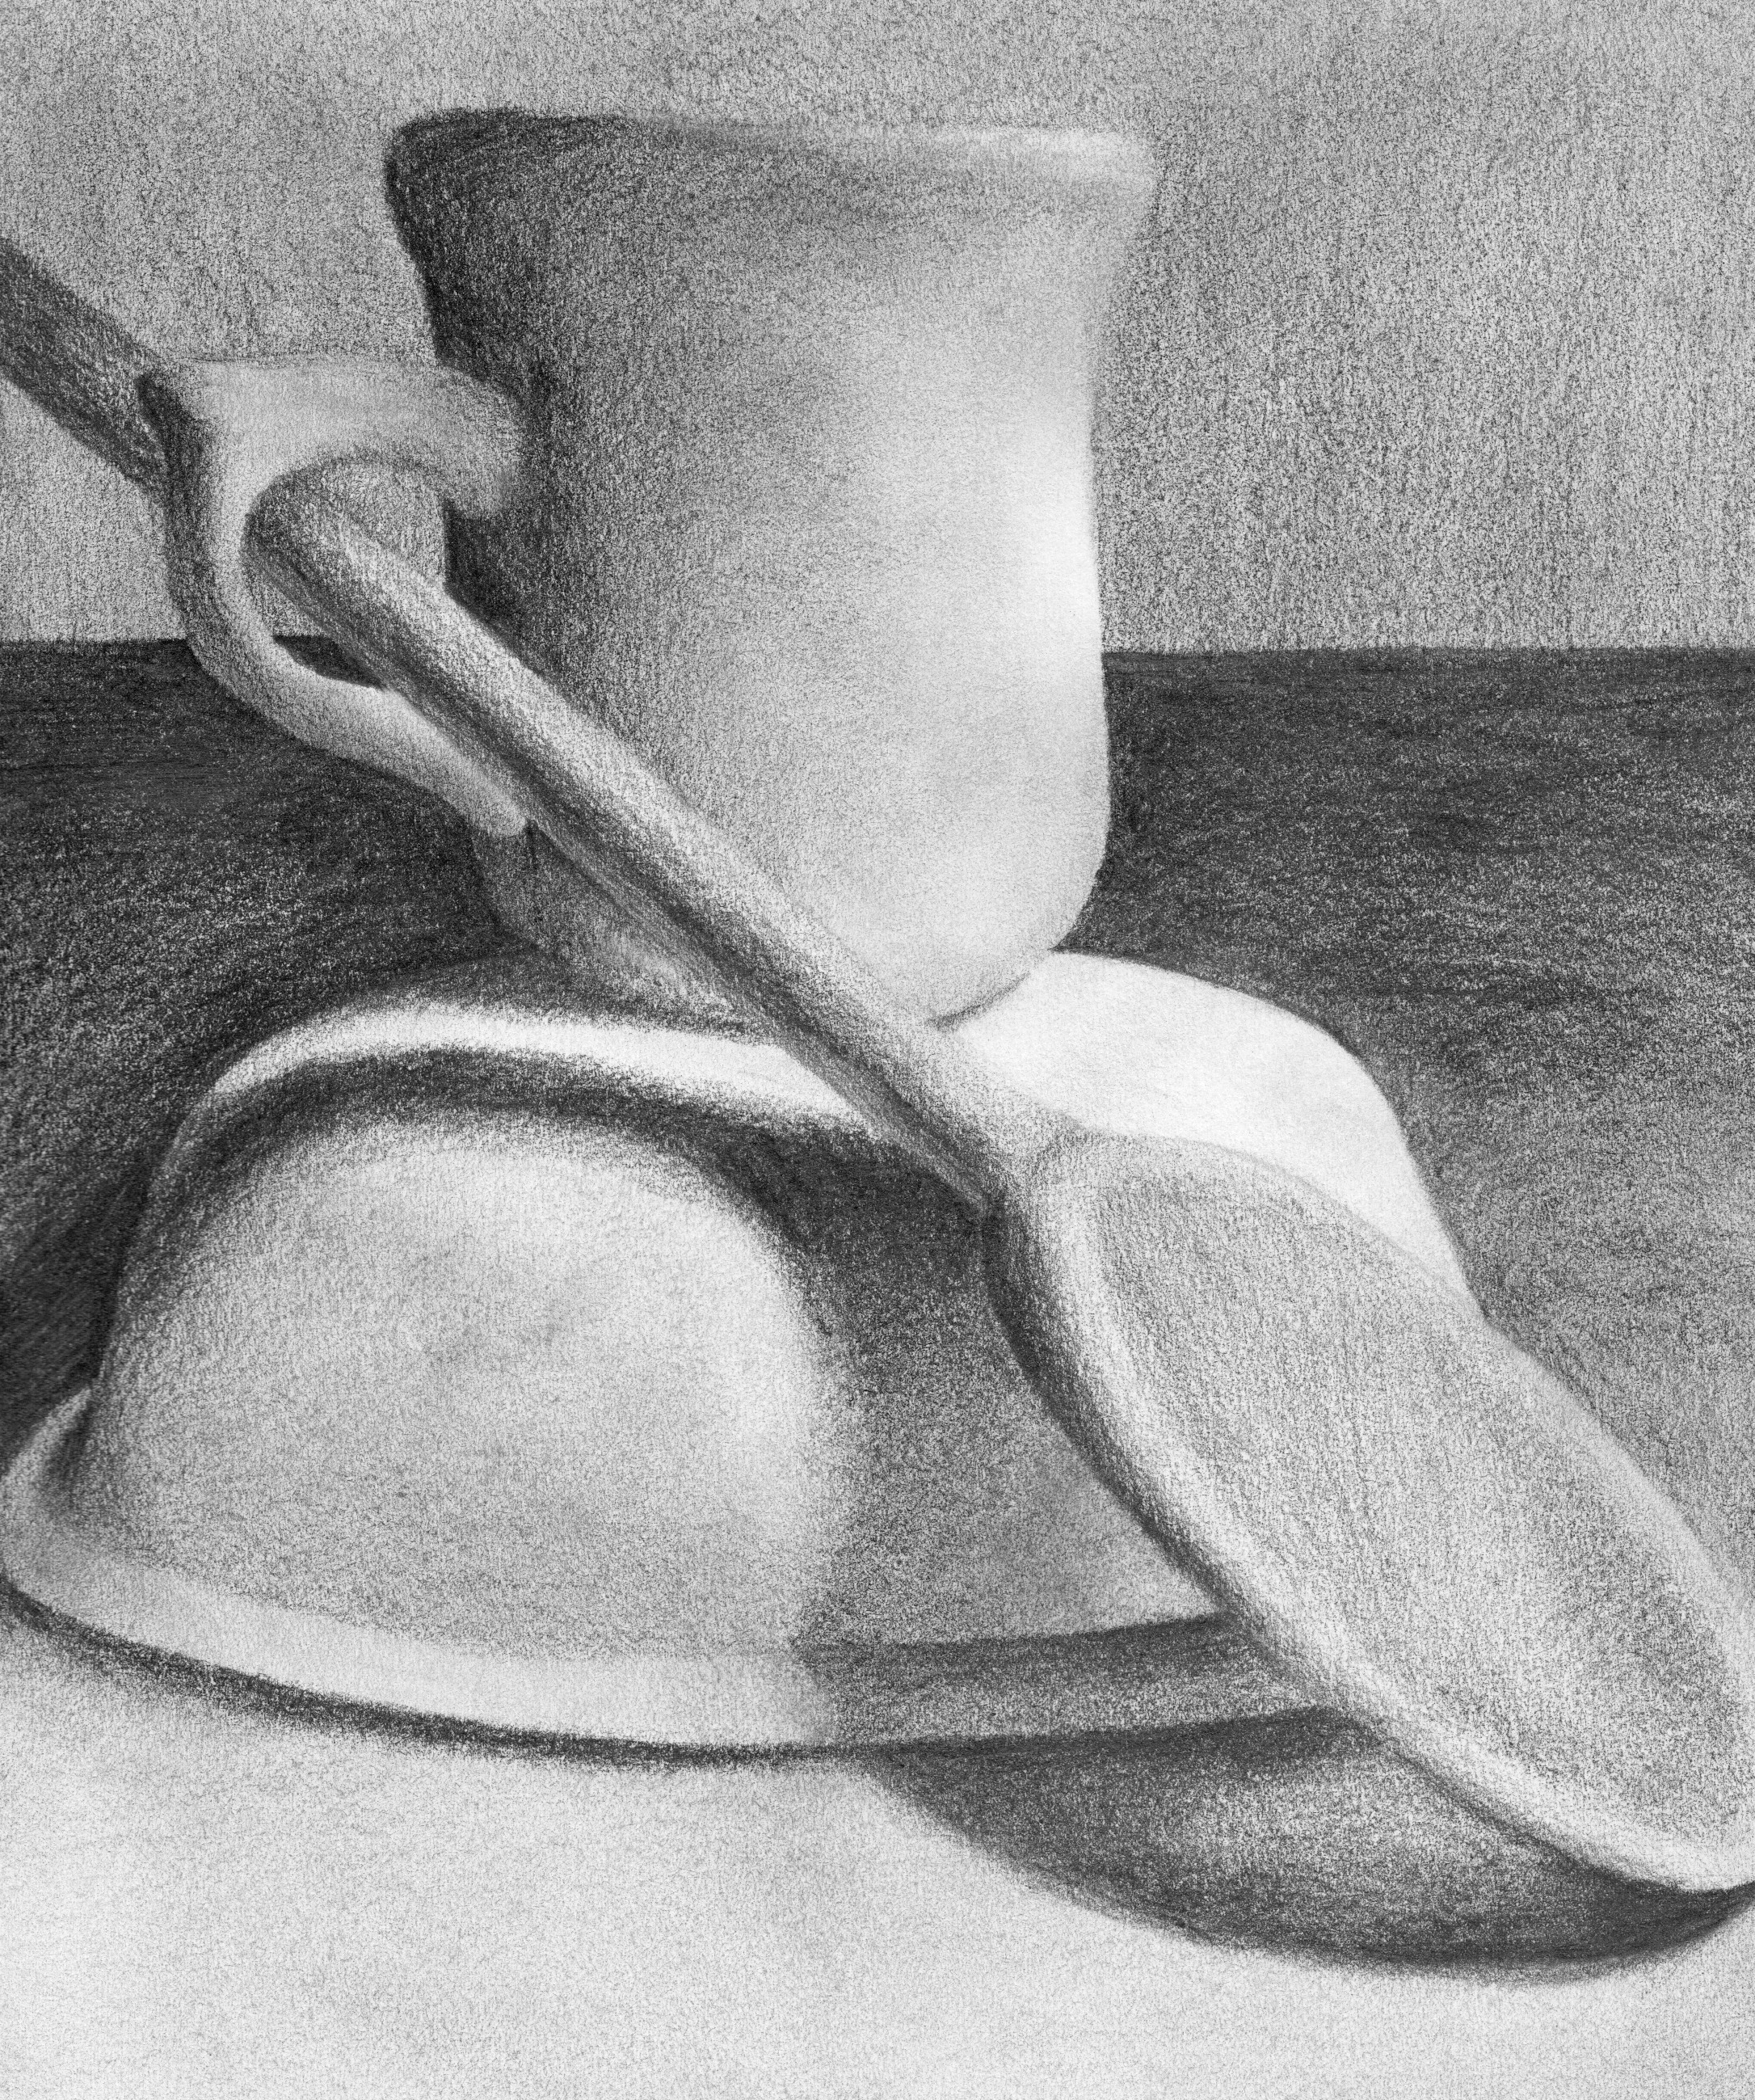
You will create a still life of 3 objects on a white or lightly colored surface. (You may use the same objects as last week
but create new thumbnails for your sketchbook.) Light your still life with only one controlled light source such as a desk lamp so that chiaroscuro can be observed. Then use a page in your sketchbook to create 6 small “thumbnail” sketches to explore different compositions. Keep in mind positive and negative shapes, how the objects (and cast shadows) relate to each other, and how they fill the page. Don’t be afraid to crop in on your objects to find the most interesting composition. Be sure each thumbnail has a border to indicate the edges of the layout. Review your sketches and choose the best composition to work from. Once you have decided, you may choose to photograph your still life.

Next you will create a final full-page detailed graphite value drawing of your chosen arrangement.

Be sure to draw large, filling your page just like the thumbnail sketch you chose. Use your hard and soft pencils to render all the different lights and darks that define the forms. Represent all the elements of chiaroscuro that you can see, including highlights and cast shadows. Keep in mind the different values of your different objects (a red apple would have an overall darker value than a white egg.)

There should be no evident line work (like hatching or crosshatching); use blending stumps or your fingers to create smooth transitions between values. You can also use the technique of subtractive tone.

Be sure to include some background (such as a darker value behind the objects), so the objects do not appear to “float” on your page. Avoid falling back into old habits of using only one pencil or drawing heavy outlines around your objects first and then shading them in.

While it is fine to indicate some edges, do not completely outline the objects (this makes the objects appear flat, which is the opposite of what you are trying to do.) Try modifying your background value to help the light object pop out or for a dark object, creating a light area so it doesn’t fall in to the shadows and getting lost.
When you are finished with your drawing, compare it to your value strips from Activity I. Do you have a full range of value represented in your drawing, or do you need to “push” your darks even darker?

You will be assessed on the following criteria:
• Assessment is complete at time of critique. (5 points)
• At least 6 different compositions were rendered as thumbnails and included in your sketchbook. (5 points)
• Final drawing shows composition and completion, including some background. (10 points)
• Final drawing demonstrates chiaroscuro and sensitivity to form. (10 points)
• Media was utilized effectively, with no heavy outlining, no evident line work, and smooth transitions from light to dark demonstrated. (10 points)
• Final drawing demonstrates a good range of value and is an accurate realistic representation of the actual objects. (10 points)

NEXT WEEK:
• Complete Assessment #4 for critique. You must show your compositional thumbnails and preparatory sketches along with your final drawing.
• Turn in Sketchbooks at the end of class next week!
Activities A-J and Assessments 1-4 should be completed and labeled.

NOTES:

