WEEK 6: Texture and Pattern
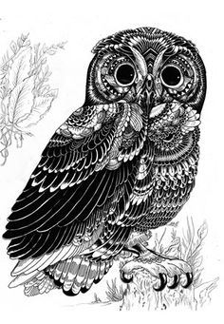
Critique of Assessment #5 -- Dürer Grid Drawing
When you pin up your assessment, you must first also pin up your reference photo or photos that you have gridded out.
When you are showing your work, be prepared to discuss the media you used (such as hard and soft pencils, blending stumps), as well as your use of the grid.
Did anyone use a blue non-repro pencil? Why? What advantages does it have?
As alsways, be open and receptive to this feedback if you are serious about improving your skills as an artist and designer. Remember that you have until the next grading period (WEEK 10) to make any necessary changes or additions.

BE SURE TO TAPE YOUR REFERENCE PHOTO(S) with your ASSESSMENT INTO YOUR SKETCHBOOK.

Presentation on Texture
The term texture is used to describe the relative smoothness or roughness of a surface. There are 2 kinds of texture: physical texture and visual texture (your textbook also refers to them as “truly tactile” or “implied.”)
- Physical texture can be experienced through the sense of touch. It can be felt with your hand. Your text calls this “truly tactile”.
- Visual texture is the illusion of physical texture, created with the drawing materials you use. This “simulated” texture gives the viewer the sensations of having “felt” textures through observation. In this class we will learn how to create visual texture in our drawings.
- Pattern When drawing; how is a pattern different than a texture? In what ways must it be handled similarily?

Activity L Close up Drawings of Texture 10 points
Drawing different textures is all about looking closely for changes in value. You will use your graphite pencils and/or grey markers for this exercise. (I have marker paper for you to use if you want to work with your grey markers.) First, draw 4 boxes on your page, each about 2” square. Then, closely examine the textured objects you brought from home.
In each box you will “zoom in” on one of the textured objects you brought in today, drawing 4 extreme close-ups of the different textures, using value, not contour lines. Look very closely and draw much larger than life-size. (Think of this as looking through a magnifying glass.) Completely fill each of your 4 boxes with texture. The object itself (the shape or form) should not even be recognizable; you are just zooming in on the texture. If you are working with graphite, use blending stumps or your fingers to blend. Using subtractive tone is also an option. If you choose to work with the grey markers, you may also use your colorless blending marker. Avoid heavy outlining. Hints: When dealing with texture, remember that heavily textured (rougher) surfaces usually have slow gradual changes in value, whereas slick reflective surfaces (such as glass or metal) often have sudden changes in value, from one extreme (white) to the other (black). Also, if you choose to work with markers: always work from light to dark, and avoid using the 100% black marker; use a dark grey instead. And be sure to allow the white of the page to show through for highlights.

*Texture and Form
You used value to create visual texture in Activity L, but what about representing texture that wraps around 3-dimensional forms?
Texture must follow the form; otherwise there is the potential for flattening. For depth and realism, you must include all the elements of chiaroscuro that define the form (highlights, shadows) in addition to the texture marks.

PRESENTATION: An Introduction to Color
Color is a very powerful element of design. Today you will be introduced to the basics of color, including the light spectrum; the color wheel; and hue, value and saturation. You will find that color is closely linked to value. In fact, successfully drawing in color depends more on correct values than on correct colors. Experimenting and working with color (as we will do in upcoming weeks) will teach you in ways that no theory can. But it is important to start with a basic understanding of color theory.

For Next Week:
• Complete Assessment #6 for critique. You must show your thumbnail sketches along with your final drawing.
• Read Chapter 8 (Color) in your textbook.
• Start gathering reference photos. They can be photos you took yourself or someone else’s, but they must be :
realistic photos, not illustrations/artwork. Any subject matter is fine; you’ll be using them in the coming weeks to create
several drawings with different color media. Next week, you will be using one of them to create a Complementary Color Drawing with colored pencils.
• Bring in your pencils, your sharpener, your colored pencils, and colorless blender pencil (sharpened and ready to go).
• Optional: You may want to bring in a flash drive (if you have one). We’ll be doing a little work in Adobe Illustrator in the computer lab over the next several weeks, and you may want to save your files.
• Reminder: Artist Presentations due in 2 weeks!

NOTES
Assessment #6 Still Life with Visual Texture 50 points

*First, arrange at least 3 textured objects and 1 piece of textured fabric into an interesting still life.
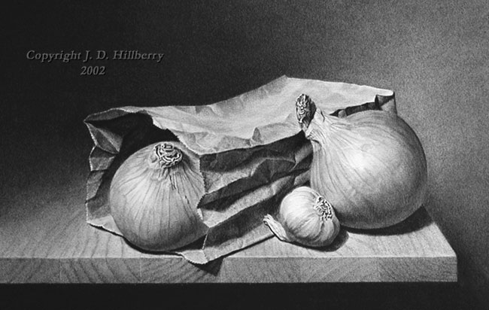
The fabric can lie flat under the objects, or wrap around them, or it can even be hung up behind the objects. Light your still life with only one controlled light source such as a desk lamp so that chiaroscuro can be observed. (Or you may use sunlight from a window as your light source, as long as it’s coming from only one direction.) You may decide to photograph the scene to preserve it if you are using natural light.

*Then use a page in your sketchbook to create 6 small “thumbnail” sketches to explore different compositions.
Keep in mind positive and negative shapes, how the objects relate to each other, and how they fill the page. Don’t be afraid to crop in on your objects to find the most interesting composition.
Be sure each thumbnail has a border to indicate the edges of the layout.

Review your sketches and choose the best composition to work from.
You may want to photograph your still life to record natural light effects or to preseverve the images of food or plant objects that will change over time.

*Next you will create a final full-page (about 8x10”) detailed texture drawing of your still life, using value only, not color.
Be sure to fill your page just like the thumbnail sketch you chose. Use graphite pencils or grey markers (or a combination of the two) to render all the different lights and darks that define the forms and textures. (Take home some marker paper if you plan to use markers.) Remember, drawing texture is all about looking closely for subtle changes in value. Also keep in mind the overall values of your different objects. (Are the objects all the same color? If not, they should have different overall values to them). Use blending stumps, your fingers, Q tips and/or the colorless blender marker to create smooth transitions between values.
You can also use the technique of subtractive tone. (If you are working with grey markers, you must allow the white of the page to show through for highlights.)
Don’t forget to include some background.
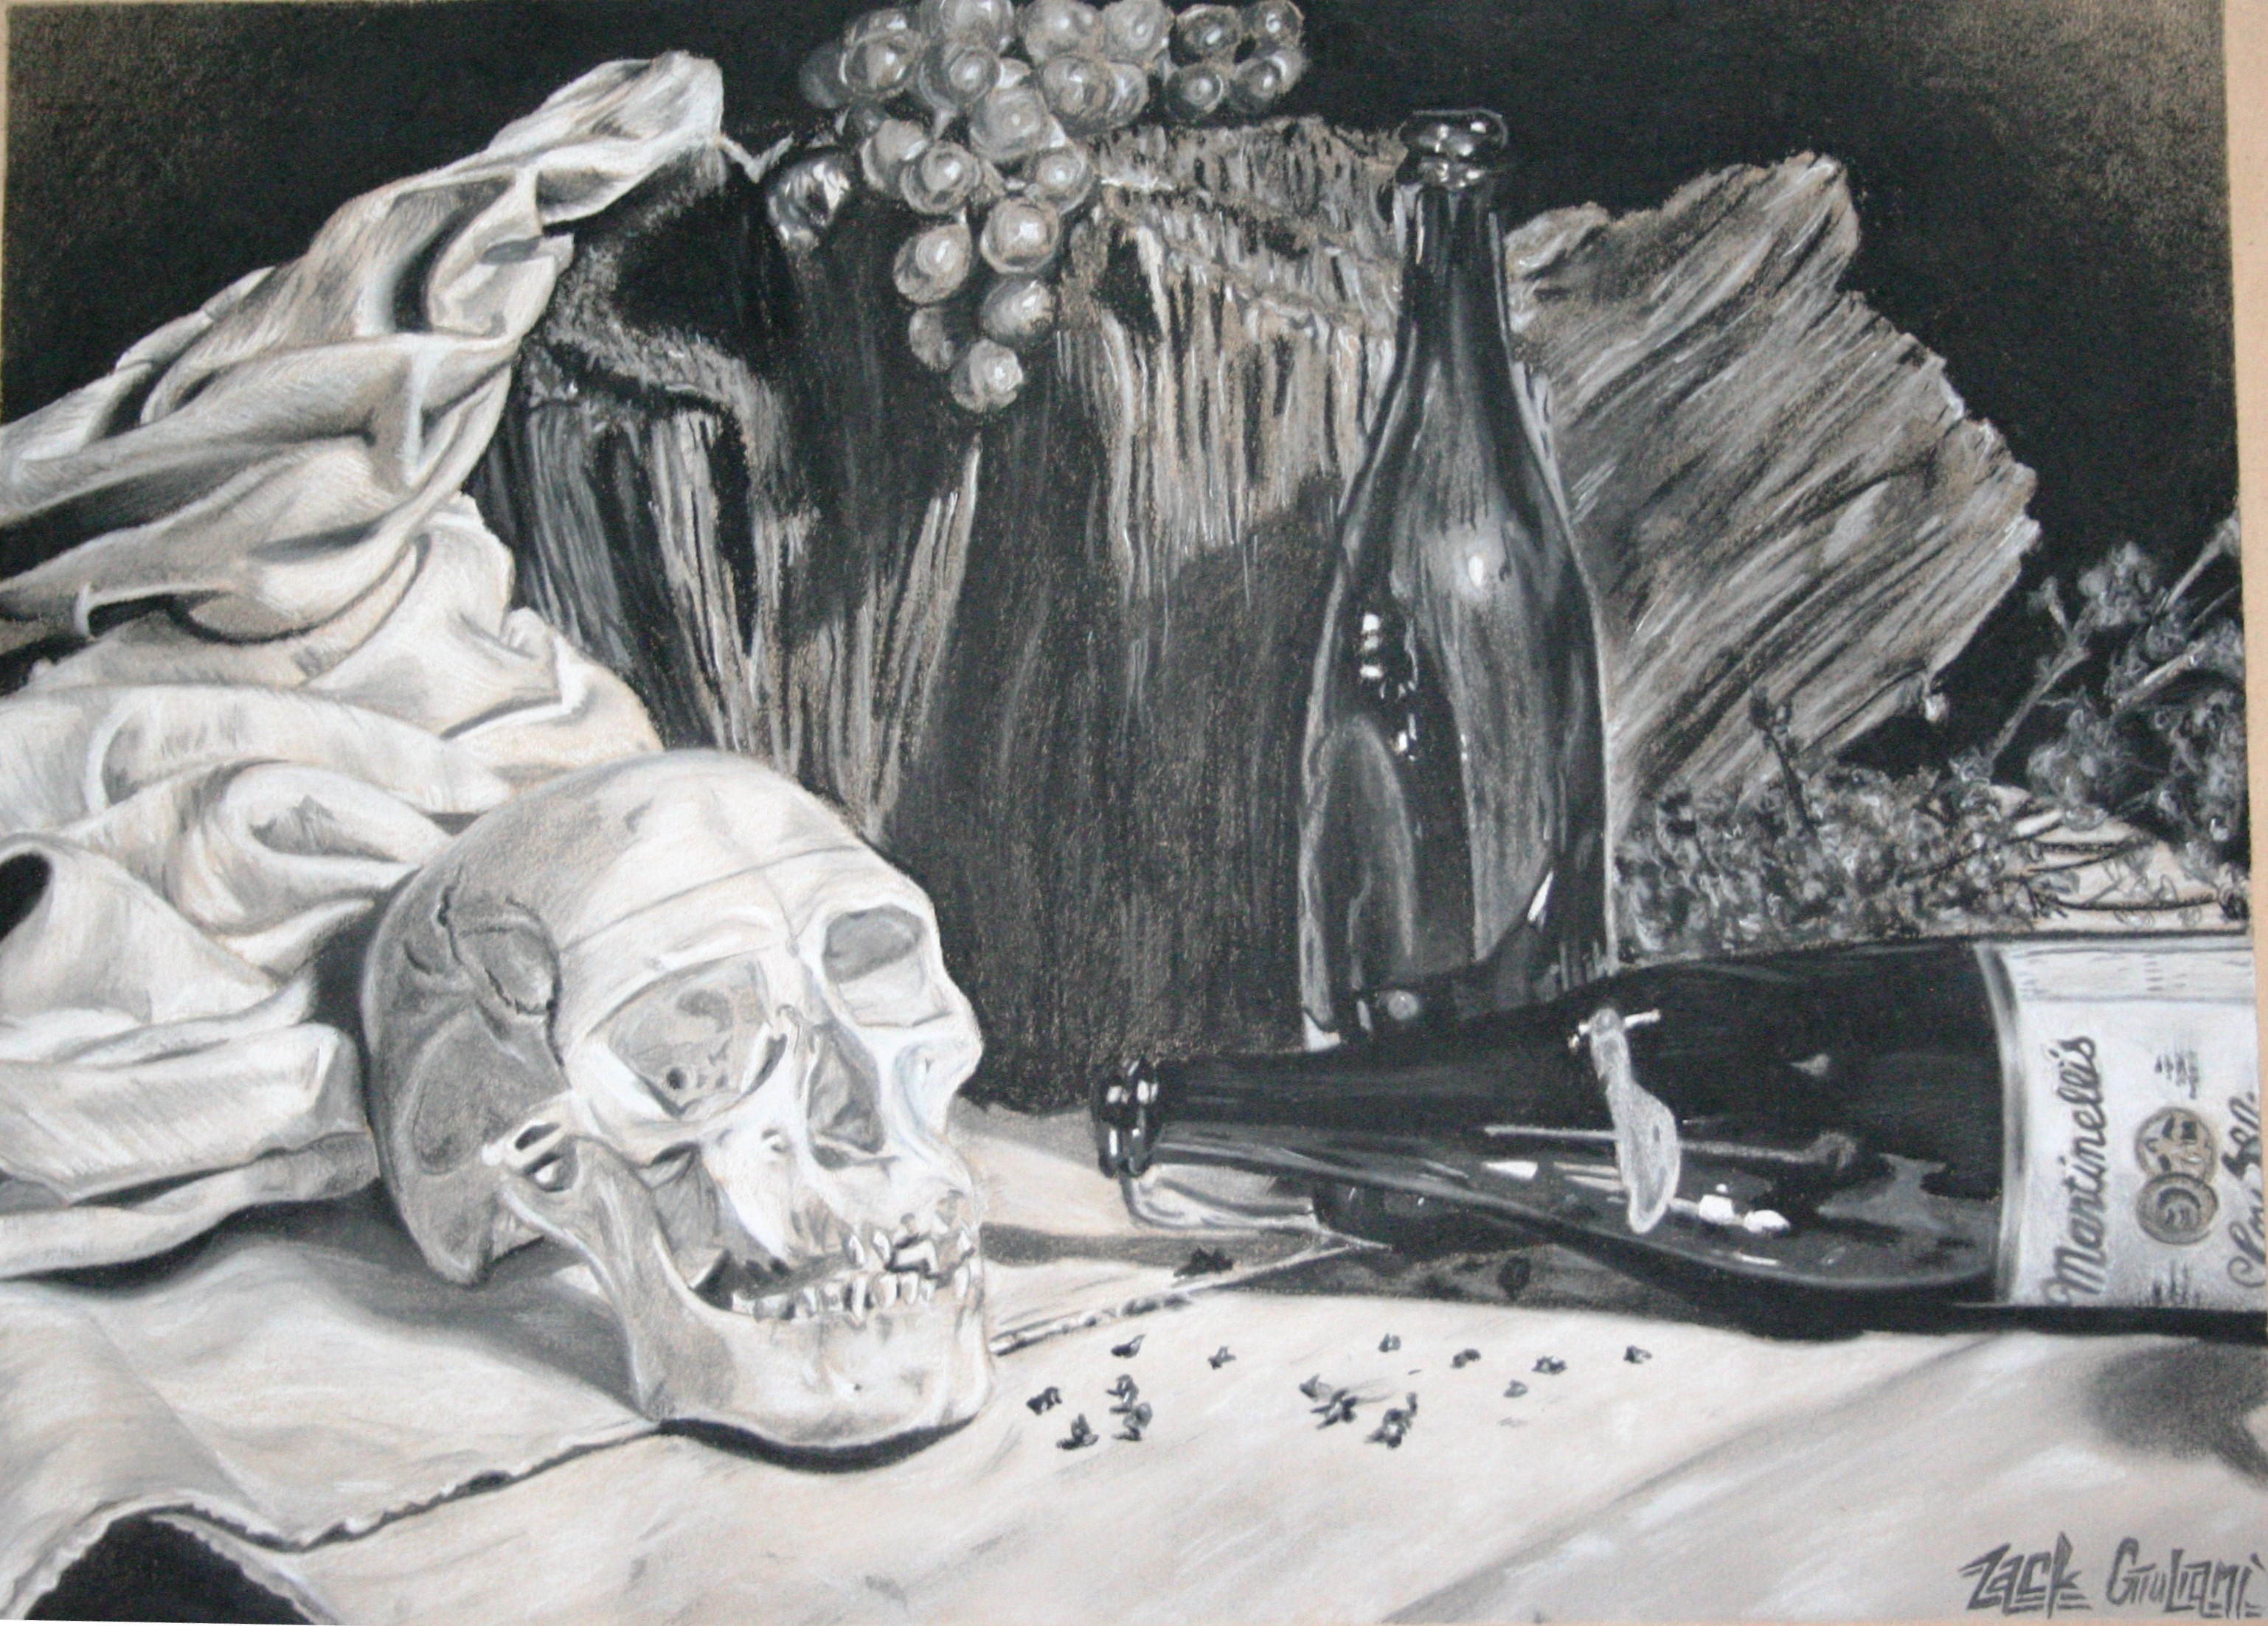
*Avoid falling back into old habits of using only one pencil or drawing heavy outlines around your objects first and then shading them in. While it is fine to indicate some edges, do not completely outline the objects. Keep in mind that the textures should curve around and follow the forms of the objects.

In addition to texture, you must also represent all seven of the elements of chiaroscuro that you can see. Pay special attention to the highlights, shadows, and cast shadows.

*Remember, if you choose to work with markers, always work from light to dark and avoid using the 100% black marker; use a dark grey instead.) When you are finished with your drawing, compare it to your value strips from Activity I (Week 4).

➔➔ Do you have a full range of value represented in your drawing, or do you need to “push” your darks even darker? ⬅⬅

You will be assessed on the following criteria:
• Assessment is complete at time of critique. (5 points)
• At least 6 different compositions were rendered as thumbnails and included in your sketchbook. (5 points)
• Final drawing shows composition and completion, including some background. (10 points)
• Final drawing demonstrates chiaroscuro and sensitivity to form. (10 points)
• Chosen media was utilized effectively to demonstrate a good range of value throughout the drawing. (10 points)
• Final drawing shows detailed textures and is an accurate realistic representation of the actual objects. (10 points)

NOTES

