WEEK 7: Color with Pencils
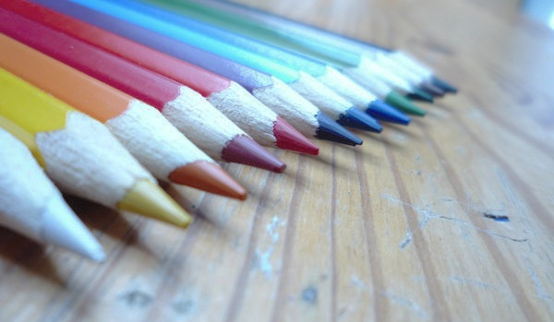
Critique of Assessment #6 -- Still Life with Visual Texture
You will present your Assessment from last week, including your compositional sketches, to the class and instructor. When you are showing your work, be prepared to discuss your subject matter, the media you used, your lighting, your use of value to show texture, and your composition. Also discuss how you feel about the assignment (the process), and the overall look of your finished piece. (Are you satisfied? What did you like/dislike? What did you learn?) The instructor and the class will provide feedback about the impression your drawing has made. Be open and receptive to this feedback if you are serious about improving your skills as an artist and designer. You have until the next grading period to make any necessary changes or additions.

Introduction to Colored Pencils
Today we will take a look at colored pencils and the proper techniques for drawing with them. You’ll have more success working with colored pencils if you follow a few guidelines such as
- keeping your pencils sharp,
- layering up the color and value gradually,
- mixing multiple colors together for even more color options
- don’t be afraid to use complementary colors to shade areas before adding in local color rather than using gray or black

Activity M Colored Pencil Exercises 10 points
You will receive a Colored Pencil Exercise template. Do not draw directly on the template. Place the template under a sheet of paper in your sketchbook and, using graphite, very lightly trace out the shapes. This is your chance to really experiment and become familiar with your colored pencils and colorless blender pencil. Your instructor will demonstrate and you will practice several things:
1. Scumbling;
2. Blending two colors into each other (not black or white);
3. Creating shades with black;
4. Creating tints with white;
5. Creating tints with the white of the page;
6. Burnishing with the colorless blender pencil (if you have one, or with white if you don’t);
7. Creating and labeling a 6-color Color Wheel (using Canary Yellow, Crimson Red, True Blue, Orange, Grass Green and Violet); and
8. Blending two complementary colors together to adjust saturation and create Tones.

Activity N Apple or Pear Drawing 10 points
You will receive a template of an apple and a pear. Do not draw directly on the template. Place the template under a sheet of paper in your sketchbook and, very lightly trace out the apple OR pear (your choice). You do not have to be exact. Do not use heavy outlines around your object. You will then use your colored pencils to render the apple or the pear as a three-dimensional form, not a flat shape. Think about where you want your light source to be, and remember to consider the elements of chiaroscuro. Keep your pencils sharpened as you work, and use the layering technique to blend colors. The more colors you mix in, the more realistic your results will be. Do not rely on just black to darken the value. Instead, mix complementary colors from the color wheel to decrease saturation and create tones. Be sure to allow the white of the page to show through for highlights, and add a cast shadow (again, don’t just use black). Keep in mind that strokes that follow the form (and curve naturally around it) will help to give your object dimension. If you wish, you may finish your drawing by using the colorless blender pencil to burnish.

Activity O Complementary Color Palette (in Illustrator or by hand) 10 points
Depending on time and availabitiy- we will make color wheels on computers or by hand using colored pencils
If you already are familiar the Adobe Illustrator Color Guide, you may use it to complete the assignment using the computers in G141. If you are not familiar with Illustrator, you may use Photoshop to create your Complementary Color Palette. If neither of these are your preferred software, you may use colored pencils and ink pens to create a neat and useful guide for your next assessment.. You will use this palette for Assessment #7. (You will also need to show this palette at the critique.) However you create your color wheel, print it out (in color) and tape it into your sketchbook

NOTES

Assessment #7 Complementary Color Drawing 50 points

First, select one of the photos you brought in to be your reference photo (or find a new photo). You may wish to combine more than one photo. You may work from black & white photos, or color photos (or both!) Remember, you don’t have to copy your reference photos exactly. Make some compositional decisions about what to include/combine/crop out/omit.
Work through some thumbnails to create a good composition. Once you decide on your composition, sketch it into your sketchbook.
(Feel free to use the grid technique to help with proportion if you want—just draw lightly). Your drawing should be about 8x10”.

Second, colorize your drawing with your colored pencils, using colors that match the Complementary Color Palette you created in Activity O. The colors of your drawing do not need to match the colors of your reference photos, but they do need to match your complementary color palette. You will likely only have a few pencils that closely match the colors in your palette; you will create the rest of the colors by color mixing on your paper. You can use any pencils you want, as long as the overall color scheme of your finished drawing looks like your palette. (For example, you may wish to mix in some yellow or blue pencils even if your palette is reds and greens. This is encouraged! The more colors you mix in, the more realistic your results will be.)

**Important notes:
Don’t forget to include
background
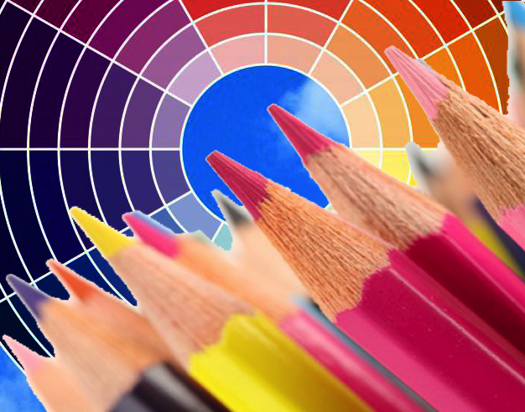
- Keep your pencils sharpened as you work, and use the layering technique to blend colors.
- Also consider the direction of your stroke: strokes that follow the form (and curve naturally around it) will help to give your objects dimension.
- Remember to consider value (and all the elements of chiaroscuro) or your forms will appear flat.
- Allow the white of the page to show through for highlights, and include shadows.
- Avoid heavy outlining.
- Remember to mix complementary colors to help create depth; don’t just use black.
- Be sure to include your reference photo(s) in your sketchbook along with your finished drawing.

Optional:
You can finish your drawing by using your colorless blender pencil to burnish if you want.

You will be assessed on the following criteria:
• Assessment is complete at time of critique. (5 points)
• Reference photo(s) are included in your sketchbook. (5 points)
• Composition is considered and background is included. (10 points)
• Only colors that match the Complementary Color Palette (from Activity O) are obvious in the drawing. (10 points)
• Drawing has a good range of value, and there is a sense of depth and light created through the effective use of complementary color mixing. (10 points)
• Drawing has detail and looks as if care and consideration were taken in its execution. (10 points)

We will critique this Assessment in class in 2 weeks. Note that working with colored pencils often takes longer than working with graphite pencils; don’t put it off!

For Next Class:
• Present Artist Report next week!

NOTES

